08.02 - Performing Maintenance
Process Design & AMOS Configuration Document
Revision
Author, Name | Date | Notes
DEOS | 17.05.2024 | Initial issue
ORDO | 13.12.2024 | Process flow modified

Purpose
This Process Design document is provided to Key-Users to record their key decisions regarding the AMOS Process design and the required AMOS configuration.
It is updated throughout the Project Definition Phase and used as the baseline for the Final Acceptance prior to Go-Live

Table of Contents
1. Process Overview & Objectives 3
2. Regulatory References 3
3. Definitions & Glossary 4
4. Process Tasks 4
5. Process Dependencies 5
6. Process Flow 6
7. Process Design Questions 7
8. Data (Source) Mapping 9
9. Other Software Used 9
10. AMOS Configuration 9
a. Basic Data 9
b. Parameters 9
c. Workflows 11
d. Scheduled Tasks 14
e. API’s & Interfaces 14
11. Annex – Additional Info 14

Process Overview & Objectives

Process General Description:
This process is usually executed by the Aircraft Maintenance department which is usually part of a Maintenance Organisation.
This process is a core process to record the execution of maintenance in AMOS. It is required for many other business processes within the organisation’s AMOS Adoption.
The trigger for this process is the assignment of a staff to a maintenance event. This assignment should be performed in AMOS but could also be performed outside if this process is not integrated.
The main benefits identified for the organisation when fully adopting this process are the following:
- Performing scheduled line maintenance will be mandatory part in integrated core end-to-end scenario. During this process live time status overview and directly triggering of related / follow up processes will be ensured. Staff can be handled / assigned on high effective and transparent way. In general this will have and positive impact on technical ground time (workpackage duration) which can be reduced to a minimum.
- Economical benefits (cost reduction) by comparing available staff vs. work performed / planned work it's possible to ensure suitable utilisation of staff and right qualifications which allows to prevent overcapacity and give possibility to do detailed human resource planning / budgeting.
- By measuring malfunctions, incomplete maintenance, extended events and related reason it will be possible investigate related processes to prevent issues and interruption which will increase work performance, aircraft availability and reduce unnecessary staff reservation / blockage.
- By monitoring live data entry it will be possible to ensure fast maintenance records processes which will make real time status possible and accelerate / improve follow up processes (e.g. material supply, etc.)
Main Process Objective (Outputs & Outcomes):
The main stake holder involved in this process is the Maintenance Production staff departments.
The main input for this process is the assignment of a task to a staff. This is usually done after the production planning phase. It is important to note that the assignment part is not mandatory to execute this process. Staff can also perform the tasks without being assigned to them.
The main outputs for this process are:
- Execution of Maintenance events
- Records of Executed Maintenance
- Recorded findings
- Record of Time bookings and material & tooling consumption/usage.

Regulatory References

The following regulatory references are linked to this business process:
- EASA Part-145 145.A.48 – Performance of maintenance
- EASA Part-145 145.A.50 – Certification of maintenance
- EASA Part-145 145.A.55 – Record Keeping
- EASA Part-145 145.A.65 – Maintenance procedures

Definitions & Glossary

Key-Words | Explanation
Workorder (W/O) | The workorder is the object were all maintenance activities are recorded. In connection with unscheduled maintenance all defect / malfunction are recorded in a workorder. The workorder can be created in different ways.
Job Card | Maintenance event that is usually linked to a parent event (WO, CR, or TC) and gets pulled in to a work package. Job cards are usually used for preparation and follow on items, or for complex tasks. Job cards can also be assigned to a workpackage as standalone maintenance execution items.
Task Card | Maintenance Event on maintenance forecast which is triggered by maintenance program requirement - this task card can be standalone on maintenance forecast and/or integrated in check
Customer requirements | Similar to Task Cards, Customer Requirements are maintenance events that are added into non-managed aircraft work packages, and are used for MRO activities.
Replacement Event | A Replacement Event is created in AMOS for each rotable, that has at least one requirement defined, which triggers the replacement of the component - rotable requirement or component document
Workpackage | The workpackage is the container for various maintenance events. Unscheduled and scheduled maintenance event can be included. Workpackages are handed over to the MRO to clearly define the scope of work.
Work Template | Work instructions which are saved as template. Main use case is the usage for scheduled maintenance events but there are also possibilities and use cases to use pre-defined templates for unscheduled maintenance.
Pickslip | Material requisition form which is send to logistic staff to inform about material request
Labelbooking | Booking of a component change
Reporting Back | Reporting Back Maintenance Event is used to report back all events that were performed on an aircraft or component. The next due date is calculated automatically after reporting back the event. The reporting back of maintenance events has two purposes:  - It generates a compliance record.  - If the event is repetitive, the next due date is calculated and the event is rescheduled in the forecast.
AMOSmobile/EXEC | Webbrowser based, touched optimised front end which is used by mechanic for work execution

Process Tasks

Main Process Task / Actions / Activities:
The following actions are performed in this Business Process:
- Review Assignment: The Staff which is going to perform a maintenance action can review his assigned work before starting it. This step is only performed in AMOS desktop or AMOSmobile/EXEC
- Review Aircraft open item list: When working on the line directly on the techlog, the staff is usually assigned to an aircraft, hence he can review the aircraft open item list and action them directly from the eTL.
- Review Documentation to perform the tasks through the Ref. Links: When reviewing the task work instruction the personnel performing the maintenance can review the documentation linked (if imported in AMOS) by clicking the links which opens the Documentation Viewer. The staff may also access the documentation directly from the documentation viewer.
- Parts & Tools Pickslip: Prior to performing maintenance the staff may have to request parts and tools. This may be done by picksliping the tools and material from the event view.
- Perform time booking: Before starting the work, the staff may start a live time booking to record the actual time he spends on the task. Note: the time booking may also be done at the end of the process.
- Enter Action: In the case of work orders, an action has to be entered against a step when the staff performs work.
- Raise finding WO: In case the staff performing maintenance has a finding during the execution of a step, a finding WO shall be raised linked to this event. Note: this can also be done at the end of the process if required.
- Close step: Once the step is finalised the user may close the step, this is usually equivalent to the stamping of the “PERF” box. Note: a step can also be indicated as not performed with a reason.
- Perform inspection: If required the inspection can be done after the performance of a step, this is usually equivalent to the stamping of the “INSP” box.
- Perform duplicate inspection: If required the duplicate inspection can be done after the inspection of a step, this is usually equivalent to the stamping of the “Dupliace INSP” box.
- Close task: Once all steps of the event are closed, the event itself can be closed.
- eSign task report: Once the final report is generated upon closure, the user usually eSigns this report to send a copy to the connected Document Management System.

Process Dependencies

The following dependencies are present for this process:
- 08.03 – Deferral Handling: If an event cannot be performed it shall be processed through the deferral handling process.
- 08.04 – Parts removal & installation: If a component change is required during this event then it shall be handled using the Parts removal & installation process, and the current process can then be resumed.
- 12.05b – Customer Quotations: When executing maintenance for 3rd parties, the generation of a finding work order then triggers the need to raise a quotation to the customer. This can be done in the customer quotation process.

Process Flow
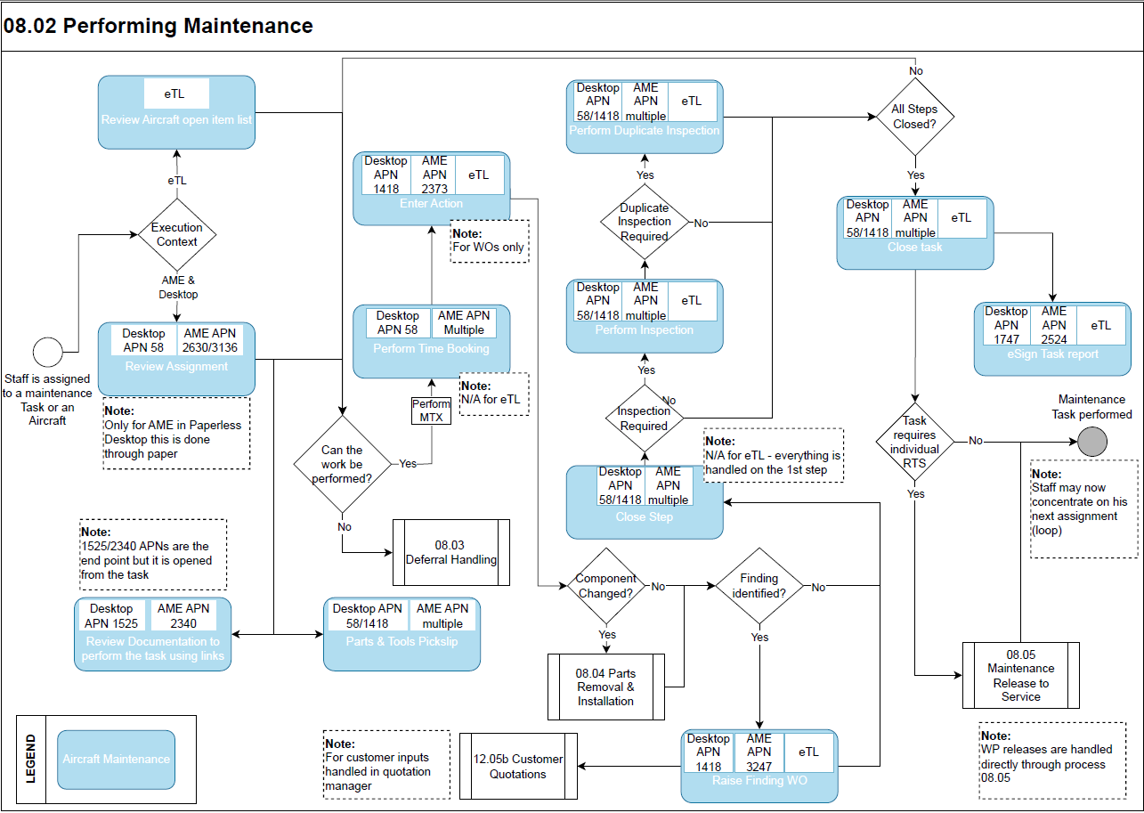
This flow chart has one main path to be followed. The time booking performance, parts & tools pick slips, document consultation and the raise finding WO items can be performed at various moments of the process. The flow chart is mainly showing the best practice flow.

Process Design Questions

# | Question | Answer
Q1 | Who will print the final “Released to Production” Workpackage?
Q2 | Do you perform scheduled maintenance at outstations? If yes which type of maintenance and who is managing this?
Q3 | Are the daily checks planned and managed by MCC or by the maintenance?
Q4 | Who is organising the workpackage items within the shift? Do you assign tasks to technicians?
Q5 | How will Project Numbers be used within Scheduled Maintenance?
Q6 | What maintenance entries must be recorded in the Aircraft Tech. Log Book (Daily Check, Oil uplift) (A-check Performed)?  E.g.: If an A-check is performed, the Scheduled W/O is printed and signed. Is an ATL entry required or the W/O attached?
Q7 | How are you managing / considering panel opening and closing times?
Q8 | How are you recording the opening and closing of panels?
Q9 | How are findings recorded which happen during routine / scheduled maintenance with and without inspection relationship?
Q10 | What is the Work Performed “closing” process? Will technicians close items in AMOS?
Q11 | Who will when create pickslips for maintenance events inside workpackage?
Q12 | Who will record the Component Label Bookings?
Q13 | Do you perform maintenance for customers?
Q14 | How would you receive Customer Requirements ? How would you enter in AMOS (interface/manually)?
Q15 | Will the parts, consumable only or rotable as well be in your stock or provided by the costumer?
Q16 | Will you issue a pickslip for 3rd party part requests?
Q17 | Who can take the decision to defer or not perform a maintenance event from workpackage?
Q18 | Who will be allowed to de-assign items from workpackage?

Data (Source) Mapping

Data Sources | Description | Volume / Manual / Automatic / Static / Dynamic
-Nil-

Other Software Used

Other Softwares | Used by: | Description
-Nil-

AMOS Configuration

The AMOS Configuration with regards to this process is very extensive. Many parameters can influence the work package behaviour.

Basic Data

Basic Data Table | Notes
Groundtime Extension Reasons | This table is used to specify the reason why a Workpackage can be extended. When extending a Workpackage it is mandatory to choose from one of these Codes.
Workpackage Priority Codes | To define the priorities of your workpackages
Priority | All workorders have a priority. The pre-defined priorities range between 1 for highest priority to 5 lowest priority including customizable special priorities are defined in this table.
Action Type | The Action Type is used to display the Header columns e.g. in the Jobcard Report
Origin Type | With Origin type the source of the workorder can be defined e.g. "D" for Document
Routine Check Type | The Routine Check types can be flagged via the Workorder APN:1418.
Priority | All workorders have a priority, worktemplates can have a priority.

Parameters

Parameter Code | Parameter Name | Notes | Settings
1110 | WP Deassignment Tracking | This parameter sets how deassignments from workpackages should be tracked. | String: Q,Q
1339 | Taskcard printing and workpackage issue workorder behaviour | With this parameter you can decide:  - Amount[Integer]: what document should be printed (task card, WO) when printing a Workpackage that contains Taskcards  - Amount[String]: Indicates if a WO should be issued when a Check or SRT is assigned to a Workpackage | Float: 0  Integer: 0  String: N;N;Y
1427 | Amount of days to show on WP browser button | This defines the default amount of days shown in the WP Browser and if the OPS icons are shown or not. | Float: 0.00  Integer: 0  String: As required
1175 | Price per manhour in ms | The float value of this parameter contains the default price per manhour used in APN 58, Statistics tab to calculate the costs of a workpackage. | Float: As required
1396 | Related taskcard logic | By setting this parameter to `Y`, the Program "View/Edit Workpackage" will also collect maintenance events that are related one to another with the relation code `W`. | String: Y
1455 | Project number mandatory in workpackage | Sets the Project number field as mandatory in View/Edit Workpackage – this is configured in the Financial Congifuration APN | -/-
1470 | Workpackage groups settings | With this parameter you can control the behavior of the workpackage groups. | Float: 0.00  Integer: 0  String: As required
1502 | Workpackage date | This parameter configures the behaviour of the WP date filter in the maintenance forecast and the default WP start and end time. | Float: 0.00  Integer: 0  String: 22:00;07:00
1523 | Workpackage assignment restrictions | This parameter influences the system behaviour for the assignment of Heavy classified items to a Line WP, and if a WO is automatically issued if a BTC is deassigned from a WP. | Float: 0.00  Integer: 0  String: As required
1529 | AMM of Workpackage | This parameter makes the AMM field mandatory for a WP. | Integer: 0
1537 | Default workpackage classification | This parameter sets the default classification of a WP | String: U
1548 | Show the electronic signature panel | The first parameter of the string value defines if the electronic signature panel is visible in APN 58, the second if it is visible in APN 3075. | String: Y;Y
1640 | WP information on PDF report | This parameter gives the possibility to print workpackage information to all PDF files linked to the Workpackage Summary reports. | Float: 0.00  Integer: 0  String: N
1650 | Workpackage number index | This parameter controls the automatic generation of workpackage numbers when creating workpackages. | Float: 0.00  Integer: 0  String: As required
1741 | Workpackage not performed, defer, release configuration | This parameter value controls the automatic de-assignment of deferred and not performed events. | Float: 0.00  Integer: 1  String: N

Workflows

Workflow Number | Workflow Name | Notes
31 | Unknown Part entered in Workorder (post-save) | This workflow is triggered if an unknown part is manually entered in Workorder
32 | Zero-Stock for Part Number entered in Workorder (post-save) | This workflow is triggered when a part-request is manually entered in Workorder without having enough system-quantity
33 | Workorder closed (post-save) | This workflow is triggered when a workorder is closed.
43 | Publish a Workpackage | This Workflow can be used to publish a Workpackage. As soon as a rule is defined a 'Publish Workpackage' button appears in Maintenance Forecast. When you press this button the workflow is executed.
52 | Workorder deleted (post-save) | This workflow is triggered when a workorder was deleted.
74 | Part Request removed / Open Order on closed W/O found (post-save) | This workflow is triggered if a part request was removed or the W/O was closed but an open order for a part request exists
98 | After saving, deleting and creating a workpackage | This workflow is started after a workpackage is created, modified or deleted.
100 | Workorder saved (post-save) | This workflow is triggered when saving a workorder.
101 | Workorder issued for a Document (post-save) | This workflow is triggered when a W/O is issued from specified list of Documents.
148 | Open Taskcards on Workorder Check Package when closing W/O (post-save) | This workflow is triggered when a Check Workorder is closed and has open Taskcards in the Workpackage linked to this Workorder.
158 | After Deassigning Events from a Workpackage | This workflow is started just after de-assigning events from a workpackage.
307 | Before Assigning Events to a Workpackage | This workflow is started just before assigning events to a workpackage.
311 | Workorder saved (pre-save) | This workflow is triggered before saving a Workorder within the Workorder module.
325 | Before saving, deleting and creating a workpackage | This workflow is started before a workpackage is created, modified or deleted.
356 | Software Post-Installation | This workflow is triggered when the user successfully installed a Software on a Functional Position.
370 | After Assigning Events to a Workpackage | This workflow is started just after assigning events to a workpackage.
371 | Before Deassigning Events from a Workpackage | This workflow is started just before de-assigning events from a workpackage.
389 | Counter Readout (pre-save) | This workflow is triggered before saving counter values within the counter management module.
390 | Work Template Update Revision | The workflow will be triggered when 'Update Revision' function is performed.
394 | Before Revised Taskcard re-Collection | This workflow is started just before re-collecting events from a Workpackage that contains revised taskcards.
409 | Dataset Notification | This workflow is triggered when a new dataset is stored in the AIM Dataset Repository. It was thought to notify the user that there is new pending datasets available or to notify the user of any status change of a dataset. This workflow can be triggered by virtually any APN dealing with AIM Datasets.
411 | After a W/P event is closed, deferred or marked as not performed | This workflow is started after a W/P event is closed, deferred or marked as not performed.
412 | Jobcard closed (post-save) | This workflow is triggered when a Jobcard is closed.
413 | Jobcard saved (post-save) | This workflow is triggered when saving a Jobcard.
414 | Jobcard saved (pre-save) | This workflow is triggered before saving a Jobcard within the Workorder module.
417 | Taskcard closed (post-save) | This workflow is triggered when a Taskcard is closed.
418 | Taskcard saved (post-save) | This workflow is triggered before saving a Taskcard within the Workorder module.
419 | Taskcard saved (pre-save) | This workflow is triggered before saving a Taskcard within the Workorder module.
422 | Customer Requirement closed (post-save) | This workflow is triggered when a Customer Requirement is closed.
423 | Customer Requirement saved (post-save) | This workflow is triggered when saving a Customer Requirement.
424 | Customer Requirement saved (pre-save) | This workflow is triggered before saving a Customer Requirement within the Workorder module.
439 | Before a W/P event is closed, deferred or marked as not performed | This workflow is started before a W/P event is closed, deferred or marked as not performed.
447 | AMOSmobile After saving, deleting and creating a workpackage | This workflow is started after a workpackage is created, modified or deleted.
449 | Feedback Workflow for AMOS Notification in AMOSmobile | This workflow is triggered when the status of an email notification change.
457 | Line Maintenance Info. Messages | This workflow is triggered to notify mechanics from Line Maintenance Manager APN
460 | Work Assignment / De-assignment Notification | This workflow is triggered to notify mechanics when a workload is assigned or de-assigned.
464 | After E-Signature on CRS Report has been made | This workflow is triggered after a CRS report has been signed via e-signature.
465 | After E-Signature on CRS Report has been made on mobile | This workflow is triggered after a CRS report has been signed via e-signature.
484 | Workpackage Changed | This workflow is triggered whenever anything releated to a Workpackage changes.
512 | Event Closed / Not Performed (Post-Save) | This workflow is started after a W/P event is closed, deferred or marked as not performed.
528 | Reopen, Undo Deferred or Not Performed events (Post-Save) | This workflow is started after a W/P event has been reopened or moved to pending from deferred or not performed t using Undo action

Scheduled Tasks

Scheduled Task Reference | Frequency | Notes
LineMaintenanceAutomaticGenerationTask | Once an hour | Automatic generation of tasks for line maintenance
QuoteWPWorkscopeComparisonTask | When required | Comparison of quoted workload and actual workload

API’s & Interfaces

Reference | Direction | Trigger | Frequency
Transfer MRO workpackage | Bi-directional | Customisable | A/R
Transfer MRO result | Bi-directional | Customisable | A/R
Transfer workpackage confirmation | Bi-directional | Customisable | A/R
Transfer workpackage_perf | Bi-directional | Customisable | A/R
Transfer workpackage | Bi-directional | Customisable | A/R
Export workpackage event planning | Outbound | Customisable | A/R
Export workpackage planning | Outbound | Customisable | A/R

Annex – Additional Info

-Nil-

